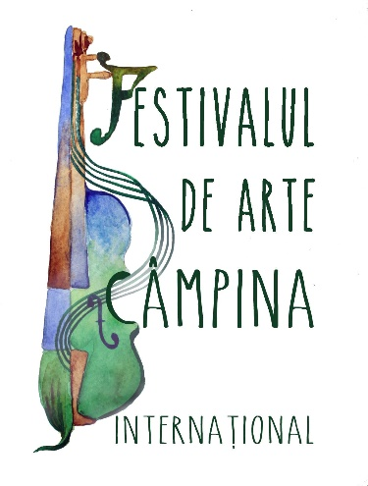

Last name ...................…….…………...........…………………………………

First name ..............………....………………….………………………………
Address: ……..…………………...…………….…….…...…….…….…...…..
City: ………….....……….…….........………………….…….........…………...
Country: ………….........….…......................
Phone number: .......................................Cell number:..................………………
e-mail:……………............……...........................................................................
Date of Birth: …………………..........................................................................

I apply to participate in the Online Bass String Instruments Contest of the Festival 4 Arts
Edition I (October 22 – December 20, 2020)

To be completed in accordance with the Rules of Bass String Instruments Contest, by December 05, 2020:

Category ......................................................................................................

Section (Group) .......................................................................................................

I participate in the contest with the following pieces (Composer - Title of the piece):

Title 1. .....................................................................................................................................

Title 2. ......................................................................................................................................

Title 3. .......................................................................................................................................

I have paid the participation fee of 20 Euro / ………… (in the case of ensembles, to be written the amount paid for all members, where each member pays 15 euro) in Romanian currency (RON) in the account of the organizer Best Bridge Services SRL opened at ING Bank, Bucharest, IBAN: RO22INGB0000999903782351 (in RON) SWIFT Code: INGBROBU.
For compliance, I enclose a copy of the payment order or bank statement. The registration fee is not refundable.
I also give my consent for the organizers to use at any time, in the interest of promoting the event, the works I send for the competition, without any restriction or financial obligation. In this regard, I attach to this form the contract - Publication agreement, signed in my own name or for the minor I represent (eg. son / daughter), as the case may be.

Date ……………………. Signature .......................................

Registration information

Required documents:

- Annex 1 - Registration slip, completed with all the requested information, Annex 2 - Publication Right Agreement, completed and signed, the Video entering the competition, sent via WeTransfer (or similar platforms) together with proof of payment of the participation fee (amounting to 20 Euro / or 15 Euro x number of ensemble members) to the email address festivaluldearte@gmail.com until December 05, 2020.
Fill in the required data in the form carefully because they will appear on diplomas and in posts. All information must be completed in capital letters.

- The participation fee (amounting 20 Euro / or 15 Euro x number of ensemble members, payable the equivalent in RON) will be paid by bank transfer to the account of Best Bridge Services SRL opened at ING Bank, Bucharest, IBAN: RO22INGB0000999903782351 (in RON) SWIFT Code: INGBROBU, CUI: 7524371. It is compulsory to state on the payment order: the name of the participant - Bass String Instruments Contest 2020 fee.

3. The video, Annex 1, Annex 2 and proof of payment of the participation fee must be sent together, in the same email.

Privacy Policy regarding the Processing of Personal Data

By completing this form, each participant or his/her parent/legal guardian at the Bass String Instruments Contest of the Festival 4 Arts 2020 - First Edition, declares that:
"I was informed that personal data will be processed in the Bass String Instruments Contest of the Festival 4 Arts 2020 - First Edition, being necessary in the relations with it. I was informed that, in accordance with the provisions of law no. 677/2001 as subsequently amended and supplemented, in conjunction with Regulation (EU) 2016/679 of the European Parliament and of the Council of 27 April 2016 on the protection of individuals with regard to the processing of personal data and on the free movement of such data, the right for data to be connected only for specific, clearly defined purposes; the right that the requested data is not excessive; the right that the requested data not be stored longer than necessary; the right to access, intervene in the data (for example, without limiting oneself to: correcting, blocking or deleting incorrect data); the right to have personal data protected against accidental, unlawful destruction, loss, alteration or disclosure; the right to request the deletion of data after their correlation is no longer necessary for the specified purpose. I give my consent for the storage, processing and transmission of personal data in the Bass String Instruments Contest of the Arts Festival 2020 - Edition I, during the relations with him and after their termination to allow the preparation of various contractual documents and payment documents."
By participating in the Bass String Instruments Contest of the Festival 4 Arts 2020 - First Edition, you give your consent for the use of personal data only for purposes strictly related to this event. After the conclusion of the Bass String Instruments Contest of the Arts Festival 2020 - Edition I, these data will be automatically deleted from our records.
By participating in the Bass String Instruments Contest of the Festival 4 Arts 2020 - 1st Edition, you agree to publish the videos entered in the contest on the Festival’s Facebook page and on its website, where they will remain public indefinitely.
In accordance with the provisions of law no. 8/1996 on copyright, each participant or their parent/legal guardian express their explicit agreement for the dissemination and storage of videos by the Bass String Instruments Contest of the Festival 4 Arts 2020 – 1st Edition I.
ATTENTION: Make sure you own the copyright to the submitted video recording.

