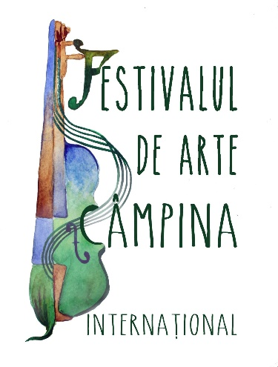

Last Name ...................…….…………...........…………………………………

First name ..............………....………………….………………………………
City: ………….....……….…….........………………….…….........…………...
Country: ………….........….….............................................................................
Phone number: .......................................Cell number:..................……………...
e-mail:……………............……...........................................................................
Age reached: ……………………………………………………………………
Supervising professor: ........................……………………………………….....
Vocational/artistic education institution: .............................................................

I apply to participate in the International Online Visual Arts Competition of the Festival 4 Arts,
3rd Edition (period May 05 – June 30, 2022 )

You must complete Annex 1 – Registration slip – International Contest to enter the competition. This, together with the proof of fee payment and the work/works must be sent by June 25, 2022. To be completed in accordance with the Rules (for minors the signature will be of the legal representative) :

Section .........................................................................................................
Age Group .....................................................................................................

I participate in the contest with the following work/works (write the title of the work, the technique and the support used, and if you participate in several sections, the title, the technique and the support for each work):

1. .....................................................................................................................................
2. ......................................................................................................................................
3. .......................................................................................................................................

I have paid the participation fee of ....…………, in Romanian currency (RON), in the account of the organizer Best Bridge Services SRL opened at ING Bank, Bucharest, IBAN: RO22INGB0000999903782351 (in RON) SWIFT Code: INGBROBU or by PayPal.
For compliance, I enclose a copy of the payment order or bank statement. The registration fee is not refundable for any reason.
Also, by signing this form I took note of all the details of Annexes 2 and 3 (where applicable) and confirm that my signature represents my agreement to those described in Annex 2 - Publication Agreement and Annex 3 - Parental Agreement.

Date ……………………. Signature .......................................

Parent name (for minor participants) ………………………………………… ..

Registration information

Required documents:

- Annex 1 – Registration coupon, completed with all requested information and signed (signing Annex 1 is equivalent to signing Annex 2 – Publication Agreement and Annex 3 – Parental Agreement, respectively), the work/works entering the competition, together with the proof of payment of the participation fee to the address festivaluldearte@gmail.com until June 25, 2022.
Carefully fill in the required data in the form because they will appear on diplomas and in posts. For teachers, the full title must be passed (eg: Dr., Associate Professor Dr. etc.)

- The participation fee is:
For indindividuals:
- 18 Euro if the registration is made until June 1st, 2022;
- 25 Euro if the registration is made between June 2 – 17, 2022
- 33 Euro if the registration is made between June 18 – 25, 2022.

By „registration” we mean the submission of works together (at the same time) with Annex 1 and proof of payment of the fee.
The participation fee will be paid by bank transfer to the account of Best Bridge Services SRL opened at ING Bank, Bucharest, IBAN: RO22INGB0000999903782351, CUI: 7524371. The payment order must include: Participant’s Name, Section and Age Group.
or
by PayPal at festivaluldearte@gmail.com.

- The registration, Annex 1 and proof of payment of the participation fee must be submitted together in the same email.

Privacy Policy regarding the Processing of Personal Data

By completing this form, each participant or parent / legal guardian of the International Online Competition, declares that:
"I was informed that personal data will be processed for my participation in the International Online Competition. These are necessary for the development of relations with it.
I was informed that, in accordance with the provisions of law no. 677/2001 as subsequently amended and supplemented, in conjunction with Regulation (EU) 2016/679 of the European Parliament and of the Council of 27 April 2016 on the protection of individuals with regard to the processing of personal data and on the free movement of such data, the right for data to be connected only for specific, clearly defined purposes; the right that the requested data is not excessive; the right that the requested data not be stored longer than necessary; the right to access, intervene in the data (for example, without limiting oneself to: correcting, blocking or deleting incorrect data); the right to have personal data protected against accidental or unlawful destruction, loss, alteration or disclosure;
I give my consent for the storage, processing, and transmission of personal data in the International Online Competition, during the relations with it and after their termination to allow the preparation of various contractual documents and payment documents”.
By participating in the International Online Competition, you consent to the use of personal data only for purposes strictly related to this event. After the conclusion of the International Online Competition, these data will be automatically deleted from our records.
By participating in the International Online Competition, you agree to publish the entries entered in the competition on the YouTube channel, on the Facebook page and on the website of the Festivalul de Arte / Festival 4 Arts, where they will remain public for an indefinite period.
In accordance with the provisions of law no. 8/1996 on copyright, each participant or parent / legal guardian expressly agrees to the dissemination and storage of recordings by the International Online Competition.

ATTENTION: Make sure you own the copyright to the submitted work/works.

